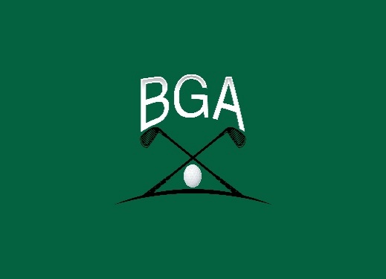
Blind Golf Association
BGA Tournament Form
Hello BGA Member,
Our first BGA tournament for the 2026 Season is being held at the Glen Abby Golf Club in Debary Fl. , February 16-21, 2026 This will be a four-day tournament. One practice round and 3 days of tournament play. All players will be required to pay for their hotel stay.. The organization will cover the greens fee and the tournament dinner. If we have enough entries, we will also be having a coach’s tournament, a closest to the pin competition, and a putting contest. The entry fee is $150 for the player and $100 for the coach if they decide to participate.
Please complete and return by December 15th 2025,. Checks should be made out to the BGA for the entry fee amount. Payments may also be made on the PayPal account to @BlindGolfAssociation.
Players Information
Name:
Address:
City/State/Zip:
Phone: Email:
Site Category: GHIN Handicap: and/or IBGA Handicap
Coaches Information
Name:
Address:
City/State/Zip:
Phone: Email:
GHIN Handicap:
Please contact me with any questions
Phillip Hubbard
386-748-9229
Pwhubbard67@gmail.com

